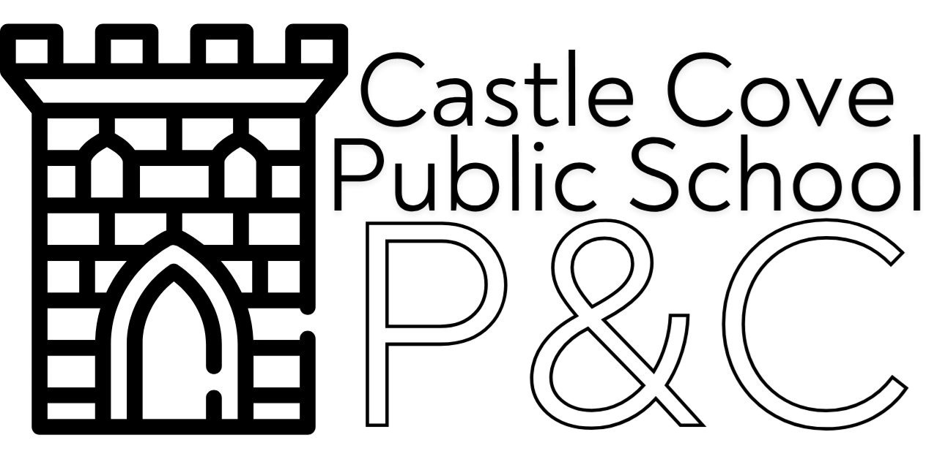

MINUTES OF P&C MEETING - 7.30pm Wednesday 6th May at The Shell CCPS & Via Zoom
-----------------------------------------------------------------------------------------------------------
PRESENT –
Jeffery Ma, Rachelle Drouza, Matthew Aspinall, Araz Mirzaian, Katie Paton, Mark Kapterian, Nicholas Johnson, Michelle Penm
Over Zoom – Mitzi Begent

7.30-8.30 pm – Presentation by Anthony Futia: Director, Shared Use of Schools team, NSW Department of Education.

**PLEASE SEE FULL PRESENTATION ON POWER POINT ATTACHED **
Take home messages:
- Castle Cove’s Situation
  - About 18–24 months ago, the P&C agreed to take on OOSH; a new 3-year lease was secured.
  - Transition processes have started, but approval as an official provider and application for relevant registrations (e.g., CCS, service approvals) have not yet occurred.
  - Current Committee Circumstances:
    - Full due diligence was not formally completed previously.
    - New committee may wish to revisit the due diligence process to ensure proper checks and broader committee involvement.
  - Transition Process Highlighted:
    - P&C must undertake formal due diligence before agreeing to take on the service.
    - Evaluation areas: conflicts of interest, financial health, operational risk, governance (including GST registration if needed).
    - Should be done independently to avoid conflicts (engaging external professionals suggested).
  - Obtain quotes/recommendations for professional due diligence support (Anthony to provide contact information from the Federation of P&Cs).
- Catherine Lee to reach out to the Castle Cove team for support regarding licensing and the transition process.

8.30-9.30 PM – ISSUES DISCUSSED:
1. Website and publicity access
Website Updates:
- Andrew Allan received details for password reset and will update
website access.
- Shared best practice examples from nearby schools (Lane Cove, Chatswood, Willoughby) for P&C and after-school care web pages.
- Emphasis on simple, attractive design targeted at current and prospective parents; linked from school website.
- Discussion of possibly adding online links to Kids Castle.
- Facebook Presence: No current Facebook page for P&C; legacy pages exist but are
- outdated.
- Action Item: Andrew to draft an updated web plan for feedback.

2. Fundraising brainstorm & expansion
- 2026 Fundraising Events:
  - Events under discussion include: cocktail parties, Northfest (June 20), discos, Bunnings BBQ, mufti/lunch order days, Ice block Fridays, Mother/Father’s Day stalls
  - Need for a central, easily accessible Google Drive folder to house all fundraising info and calendars.
  - Community Fundraising Innovations:
    - Explore merchandise (T-shirts, caps) to generate funds from the wider community.
    - Trial T-shirt sales at Bandcamp: shirts cost $18, sold for $30

3. CCPS 75 year anniversary (2027)
- Early-stage planning for a major fair/festival (street closure, rides, petting zoos, stalls, food trucks, etc.) to coincide with 75th anniversary in late August or early September 2027.
- Subcommittee sought; 6-8 organisers needed – Jeff to recruit
- Leverage local businesses and parent expertise; consider silent auction and additional digital fundraising tools.

4. Castle Cove progress association attendance – Jeff penciled for 26th May at 7:30pm then attendance on rotating basis with Rachelle and Araz
5. Lollipop man has been hired . funded by DOE

6. P& C survey implementation
- Need for improved feedback, with preference for Google Forms (over previous SurveyMonkey).
Focus areas: funding priorities, Kids Castle feedback (usage, perceived value, barriers to enrolment).
Suggestion to leverage AI for survey design.
Action: Create draft surveys (separate for P&C and TKC if needed) circulate for input.
Template available from 2 years ago platform - survey monkey or Google forms

7. Meeting with McGrath and follow up // introduction with Tanya and Rob Samuel
- Matt to follow up w Sharon with quarterly invoice w donation
- Present McGrath with major events
- Major sponsor provides $20,000–25,000/year via commission and donations.
- Need to ensure sponsor is consistently recognized and invited to key events.
- Action: Improve sponsor communication, physical invites, opportunities to present awards, etc.

8. Wellness program update
- Interest in practical, skill-based education for students (lunchbox prep, responsibility).
- Suggestion for external experts (possibly from vocational education) to run practical and wellbeing sessions for parents and students, both in-person and via Zoom.
- Plan: Andrew to connect with an early childhood expert for possible session; target is to set an event soon.
- Wellness session structure: Split sessions (for children/for parents), focus on practical life skills and nutrition.

9. Working bee event
- Annual working bees have been plagued by weather.
- Major Department of Education clean-up scheduled for May 15; P&C to
coordinate parent working bee afterwards for additional work (mowing,
gardening, painting, possible upgrades to aftercare spaces).
- Discussion of limits on what parents can do (e.g., can’t alter poles, but
can plant/clean/small enhancements).
- Facilities in focus: especially K–2 staffroom and bathrooms, which are
reported as run down.
- Pending quote and possible joint funding with school/department.
- Action: Reassess facility upgrade options after quotes and DoE decision.
Potential target for working bee can be revamping the TKC room – Matt Aspinall is happy to lead this but need to check if this needs to be voted on & budget

10. TKC
- Kids Castle 2024/2025: $50k and $67k annual loss.
- discussion around fee increase

11. Additional items
- Defibrillator: approve purchase of replacement pads P&C Exec For 2026 budget
- replacement pads (annual cost) $384.85 required.

12. Next P& C meeting scheduled May 25 7.30 pm

Action Items:
- For TKC transition – TKC sub-committee is to take ownership of the process led by Jeff/ Matt and will report back progress at each P&C meeting
- Working bee- revamping TKC room – Matt happy to lead
- McGrath action item – Matt to send invoice
- 75th anniversary item – appointment of sub committee e.g. Amanda Baylis

